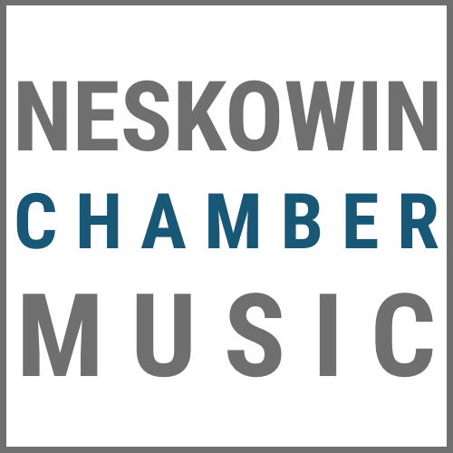

WWW.NESKOWINCHAMBERMUSIC.COM
503.965.6499

2021-2022 Season Ticket Order Form

Name: ________________________________________________________________________________________________________________

Street Address: ________________________________________________________________________________________________________

City: __________________________________________________________________State:___________________Zip:_____________________

Phone: _______________________________________________ Email: ________________________________________________________

Number of Season Tickets: ________________ Purchase Amount ($130 x number of tickets): $_____________________

Please mail your form to (checks payable to: “Neskowin Chamber Music”):

Neskowin Chamber Music
PO Box 1044
Pacific City, OR 97135

